**Functional Document**

|  |  |
| --- | --- |
| **Application** | NGERP – Centra |
| **Service Bundle** | Purchase Management |
| **Service Request** | Batch Complete NTA AP Payment |

**Decription:**

In Compiere (NGERP - Centra), the Batch Complete NTA AP Payment process is designed to finalize the accounts payable transactions in batches, ensuring accurate and timely payment processing to vendors.

**Workflow Process:**

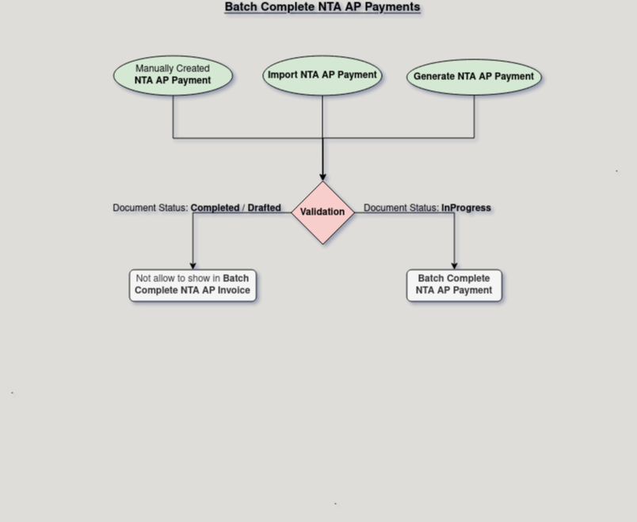

**Business Rules:**

* It is visible only in **HQ.**
* **Creation** is also possible in **HQ.**
* **Invoices** must be fully **Completed** before being included in the payment batch.
* Payment terms must be checked to ensure that the payment date aligns with vendor agreements.